**SCIENCE –** 

**POST-NORMAL PERSPECTIVES**

**Jerry Ravetz at 90**

A Workshop

31 May 2019, 9.30 – 6.00

Oxford Martin School, 34 Broad Street

Oxford OX2 3BD

The workshop will explore several themes that have long concerned Jerry Ravetz: the future of science, of post-normal science, and of policy-related mathematics.

How will the essential fiduciary status of science be preserved, when it is absorbed into STEMM, and threatened internally by the ‘irreproducibility crisis’ and externally by the populist rejection of elitist expertise?

As Post-Normal Science becomes a movement of ‘informed critical resistance’, how will it distinguish between real science done by good citizens and pseudo-science done by bad populists?

Policy-related mathematics is infected by fallacious statistical inferences, patently unfalsifiable simulation models, spuriously quantified indicators of quality, and sorcerer’s-apprentice algorithms. How can our scientific culture be weaned from its teddy-bear numbers?

Jerry will post brief statements on each theme on the workshop website, together with links to background literature. Members of the workshop are invited to contribute their comments, either before or at the event.

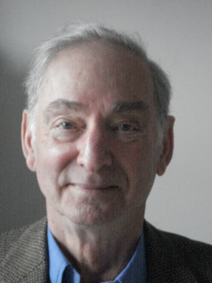

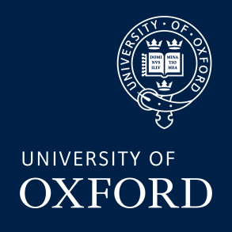

**For queries please contact:** [**enquiries@insis.ox.ac.uk**](mailto:enquiries@insis.ox.ac.uk)

**To register visit:** [**https://science-post-normal-perspectives-ravetz-at-90.eventbrite.co.uk**](https://science-post-normal-perspectives-ravetz-at-90.eventbrite.co.uk)

**For more information visit: <http://www.insis.ox.ac.uk>**

**For queries please contact:** [**antonella.surdi@insis.ox.ac.uk**](mailto:antonella.surdi@insis.ox.ac.uk)

**To register visit:** [**https://mary-douglas-memorial-lecture-2019.eventbrite.co.uk**](https://mary-douglas-memorial-lecture-2019.eventbrite.co.uk/)